How stage a SRX Firewall
1 Introduction 2
2 Prerequisites 2
3 Overview 3
4 Step-by-step plan 4

Introduction
This manual is intended as guide for staging a srx firewall

Prerequisites
- Filled in xls Template file
- Console cable
- Latest firmware version (Meso)
- When reusing a firewall from another site or ship, first ask SE to delete the firewall from Junos Space

Overview
- Perform step 1
- Perform steps 2 -> 17 on device 1
- Perform steps 2-> 17 on device 2
- Perform step 18
- Preform step 19
- Perform steps 20 -> 24 on device 1
- Perform steps 20 -> 24 on device 2
- Perform steps 25 -> x only on device 1

Step-by-step plan
- Use the manual “JDN Standaards - Junos – Completing xls Template” in order to get the needed information.
- Prepare an usb stick with both the configuration file and the junos version.
Both SRX100 and SRX240 use the same software, both are SRX branch models.
Put the files in the root of the usb drive.
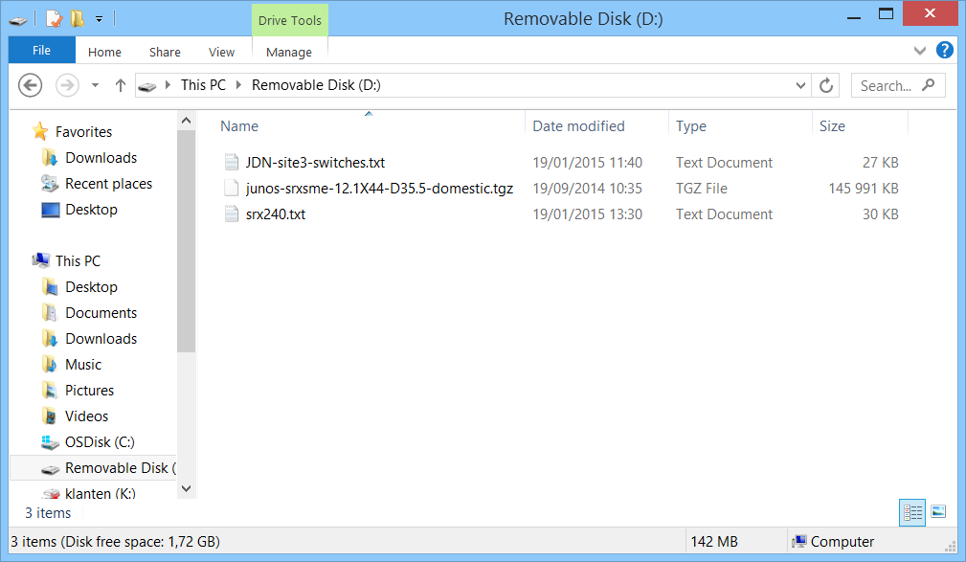
- Connect the serial console cable
The first RJ45 port on the left side is marked “console”
( do note that the top row of modules are empty )
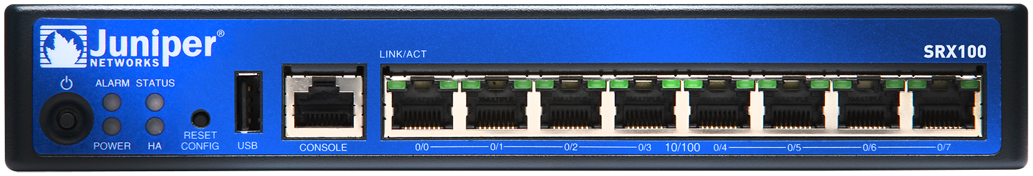

- Boot the firewall and track it’s progress via the console
The device is booted when you see the login prompt:
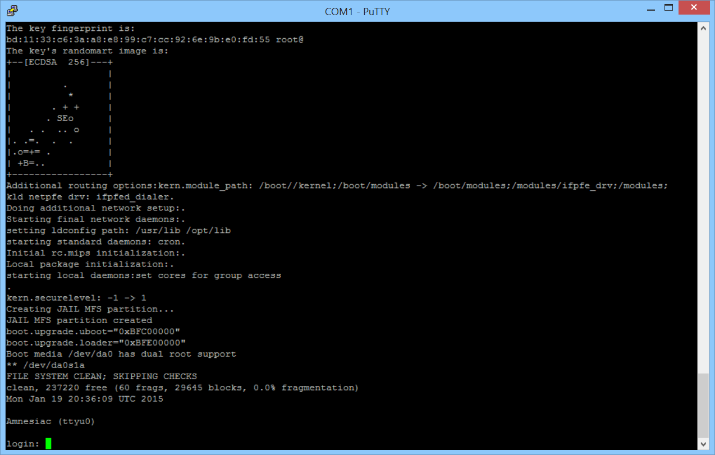
- Login with the username “root” and no password (you will not be prompted for a password)
You will get a new prompt

- Plugin the USB stick

  - SRX100 : front panel to the left of the console port
  - SRX240 : front panel to the right of the interfaces (there are 2 slots pick the one on the left )
When properly connected you will see input in your console:
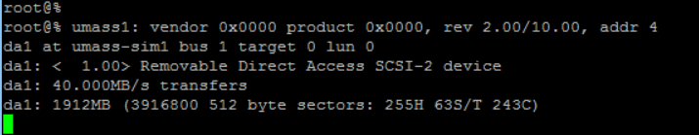

- Mount the usb stick with the following command
mount –t msdos /dev/da1s1 /mnt
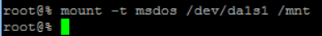

- Copy the files to the temp directory
cp /mnt/<filename> /var/tmp
(Do this twice: once for the junos package, once for the config file)

- Check if the files are properly copied:
ls /var/tmp
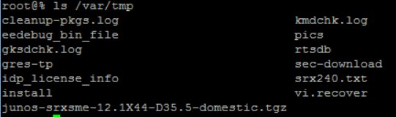

- Unmount the usb stick
umount /mnt
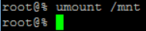
- Unplug the usb stick.
- Go into operational mode :
Cli
Again you will see a new prompt
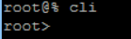
- Upgrade the software on the SRX
Request system software add /var/tmp/<name of junos package> unlink no-copy no-vaildate

The command is entered on 1 line as 1 command, many ssh/serial-console clients will not display the command completely as it is too long, see below

This command will take a while to complete (even longer if not all options are included)
The output should be something like:
(Version numbers are different because a different package was used)
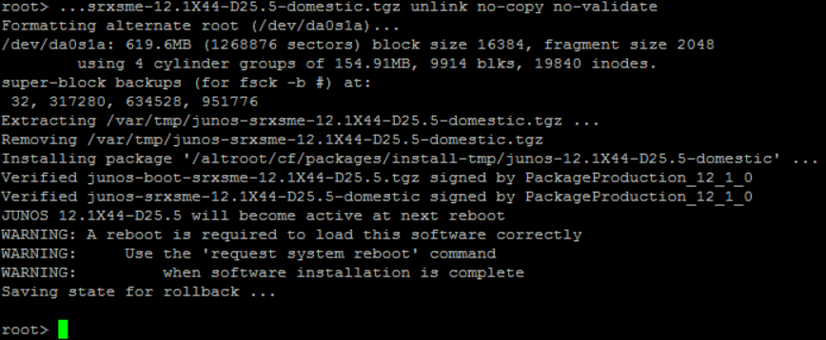

- Clustering : activate the clustering mode command is different on each unit of a cluster. The cluser-id can be found in the filled in template (Cell Information!J10). The cluster-id corresponds to the site id.
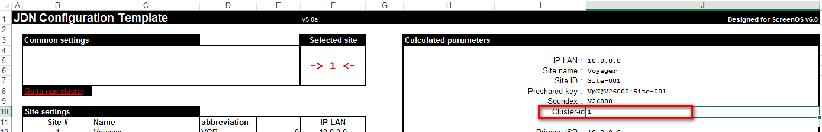
The node number will be 0 or 1 each cluster must consist of “node 0” and “node 1”
Set chassis cluster cluster-id 1 node 0 ( on the first device )
Set chassis cluster cluster-id 1 node 1 ( on the second device )

- Go into configuration mode
edit

- Delete default configuration and set a temporary root password
delete security
delete interfaces
delete vlans
set system root-authentication plain-text-password (use Juniper as temp password)
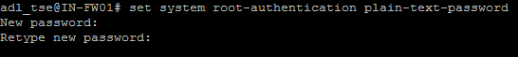
- Commit the changed configuration
Commit

Step 18: On both devices at once
- Connect the control-link and fab-link between both srx240s

Connect 0/1 ports on both devices with a cable.
(This is the 2nd interface starting from the left (not including the console) , refer to the picture above )
Connect 0/15 ports on both devices with a cable.

Step 19: On both devices at once
- Reboot the device to activate the new junos package and clustering
Request system reboot

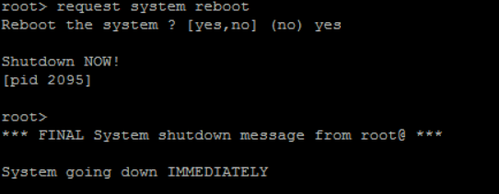

Steps 20 -> 24: (first on device 1, then on device 2)
- Wait for the system to come up again.
- Login with the root user
- Go into cli mode ( notice the changed prompt )
Cli
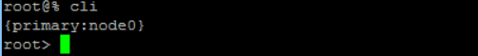
- Copy the junos package to the backup partition
Request system snapshot slice alternate
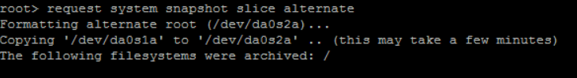
- Check if both partitions have the same and correct version installed.
Show system snapshot media internal
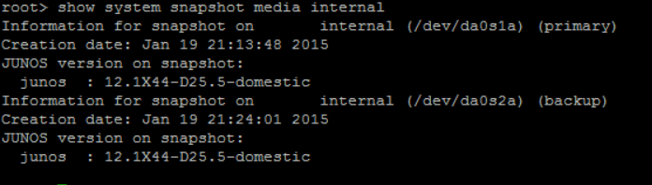

Steps 25-> x (only on device 1)
- Check the cluster state
Show chassis clusters status
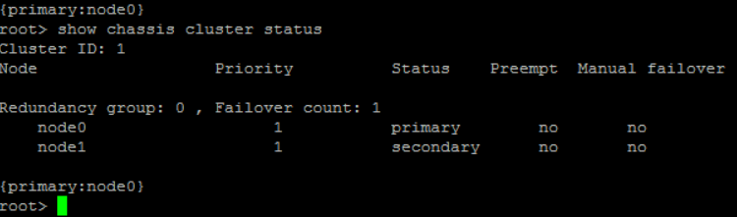

Important here is that state primary and secondary are visible and that the priority of both devices is 1.
If this should not be the case then clustering is not ok and should be checked.
Check the cluster-id. The cluster-id must be equal to the site-id.

- Go into configuration mode

edit

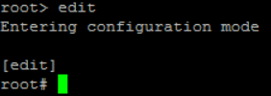

- Load the config file
Load set /var/tmp/<config-file-name>

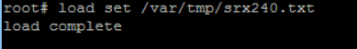
There should be no other output then the above, if there is other output an error has occurred and must be attended to before sending the device out!
- Add the adl_tse user configuration. In the xls template you can find the commands to create the user in tab “F2”.
First copy:
“set system login user adl_tse uid 2002 class super-user authentication plain-text-password”

- ONLY FOR VESSELS - Add the srv_iris user configuration. In the xls template you can find the commands to create the user in tab “F2”.
First copy:
“set system login user srv_iris uid 2002 class super-user authentication plain-text-password”
When asked copy the password
- Commit the config file
Commit
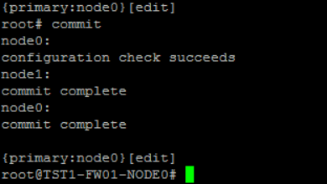

If the commit does not complete or completes with errors, then this should be addressed.
- Check if the interfaces received their correct IP addresses.
Run show interfaces terse
Look for the interfaces assigned to “reth” interfaces (see partial output below)
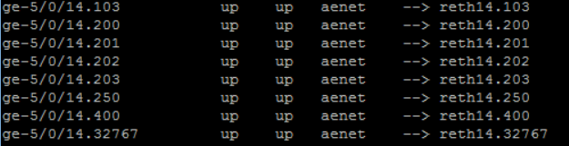
Look for the “reth” interfaces with ip addresses assigned (see partial output below)
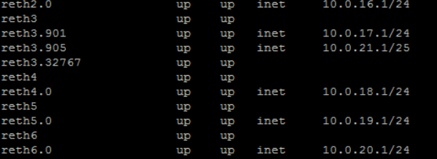
- Return to the cli
exit
- Set up idle cli timeout
- Create a rescue config
request system configuration rescue save
- Check for errors (resolving errors cfg chapter 5)
Show system alarms
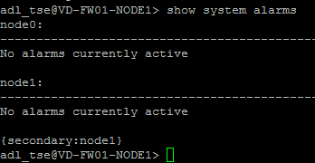
- Properly shutdown the firewall
Request system power-off

Tips and Trics

- Switch nodes:
request routing-engine login node X

- Resolve alarm “Rescue configuration is not set”
request system configuration rescue save

- Resolve alarm “Autorecovery information needs to be saved”
request system autorecovery state save

